Simulation of ICD Cholera entity enriched with Mondo cholera synonyms
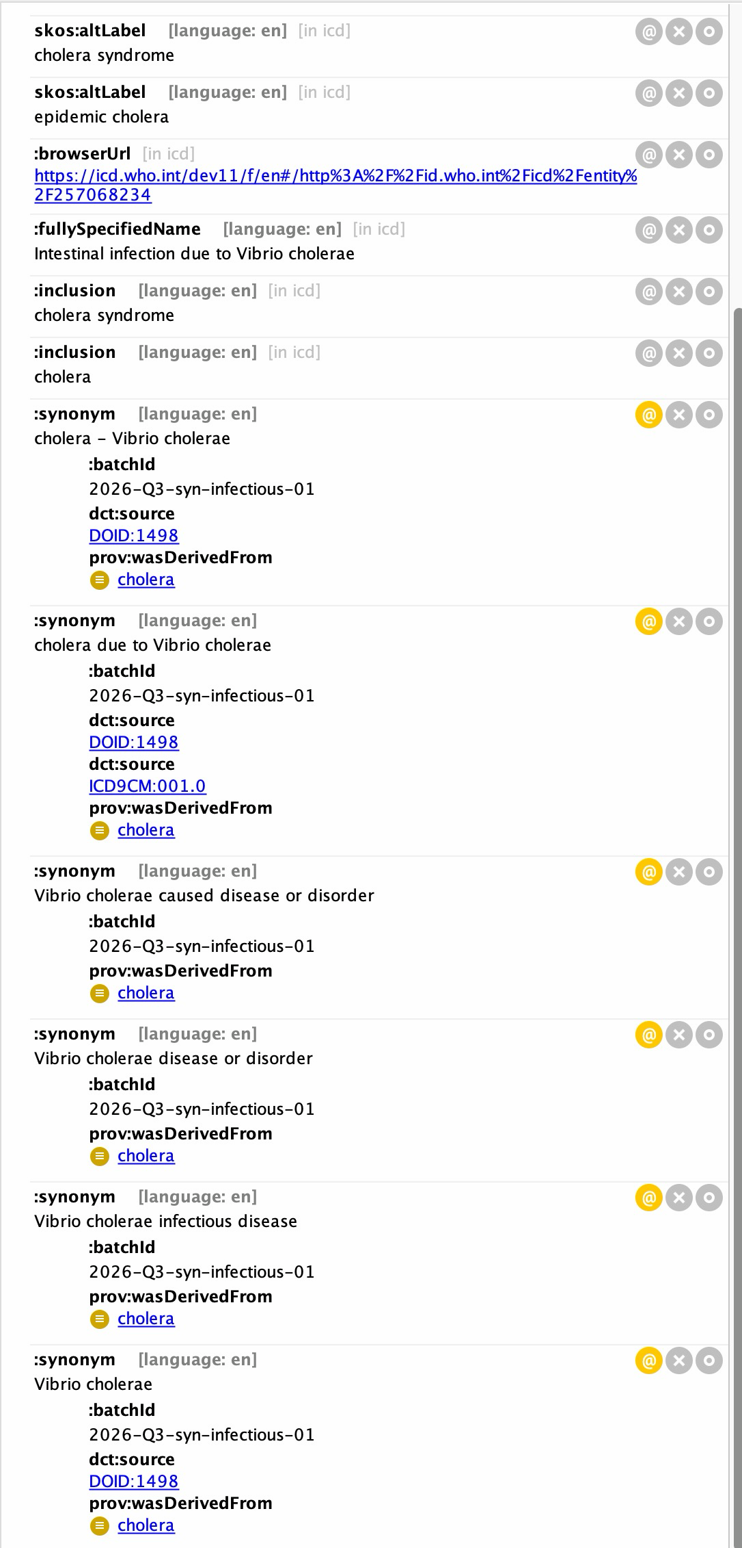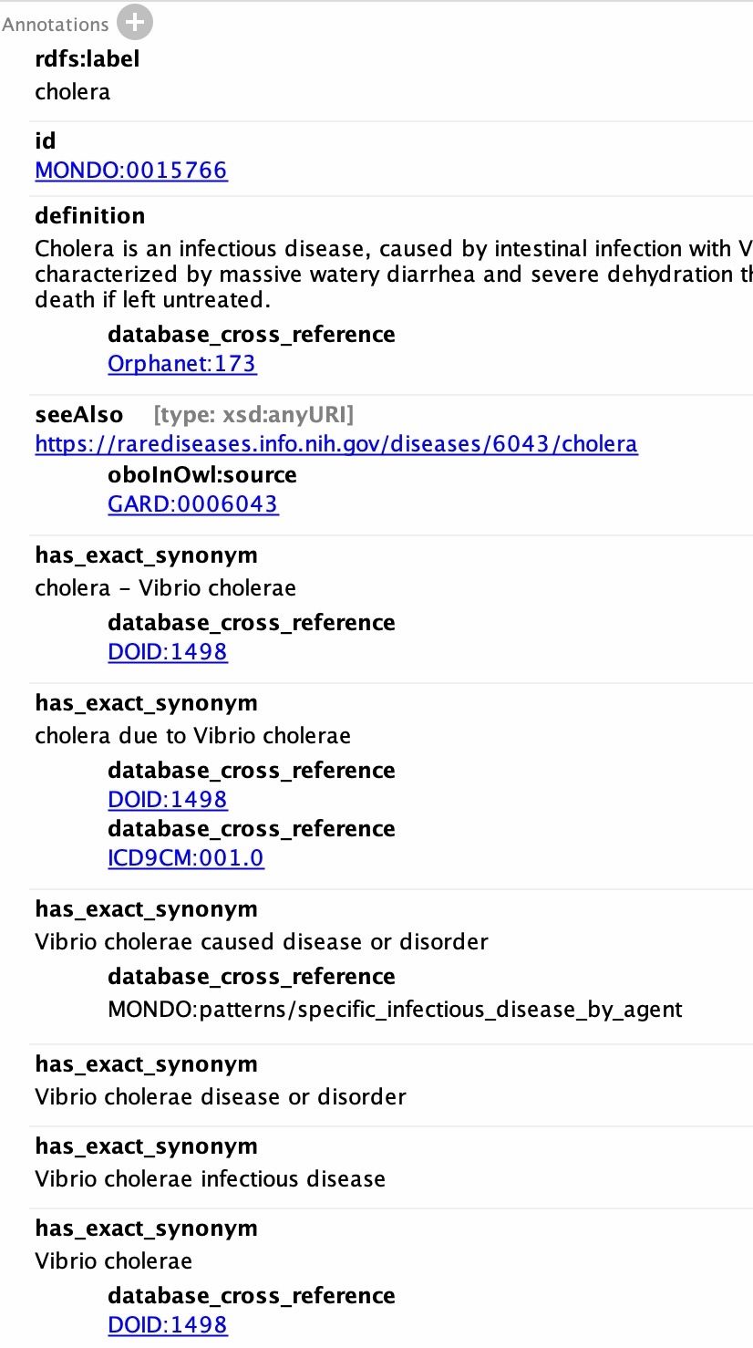

Simulation of enriching the Foundation with subclass tree and logical definitions.
